  WHAW POE  Varsity college | student numbers:  ST10497775  ST10469669  ST10496115  Binary Brains  GROUP 1

Table of Content
1.Milestone2-----------------------------------------------------------------pg1-5
Phase-1-------------------------------------------------------------------pg1
Phase-2-------------------------------------------------------------------pg2
Phase-3----------------------------------------------------------------pg3-5
Library of components used ---------------------------------------------pg.8

2. Milestone 3-----------------------------------------------------------------pg.9-20
Website changes----------------------------------------------------------pg.9-12
Mobile app changes------------------------------------------------------pg.13-19
Library of components used--------------------------------------------pg19
Reference list ------------------------------------------------------------pg.20
AI disclosure in this report --------------------------------------------pg.21-24
1.Milestone 2
Phase-1
Objectives:
Select the best logo.

Based on our previous assignment Milestone 1 All Members of a Team were required to design a logo that’s simple, professional and visually appealing to eye ,that matches the scenario empowering the nation using any online tools such canvas, BarndCrowd,.etc.

Logo-1(ST10497775) (BADIANYAMA MUTOMBO BLESS)
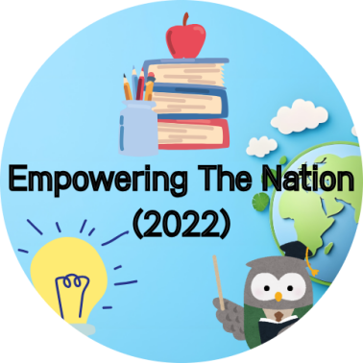
Logo-2(ST10469669) (KAY)
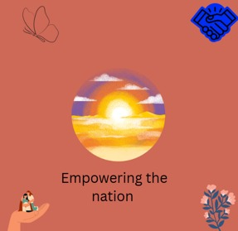
Logo-3(ST10496115) (SALLY)
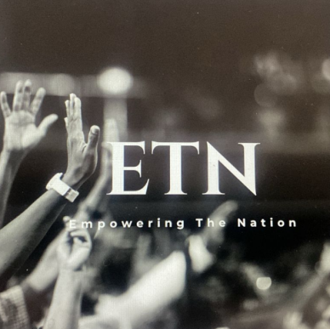
Conclusion
After Careful evaluation and thoughtful considerations, we came to an agreement on the best approach to move forward we will be selecting logo-1 for future project.
Phase-2
(assigned to ST10469669)
Objectives:
Provide detailed designs for the web page which includes the user interface, colours, functionality of buttons and links, SEO/tags Designs for each page are required

Website
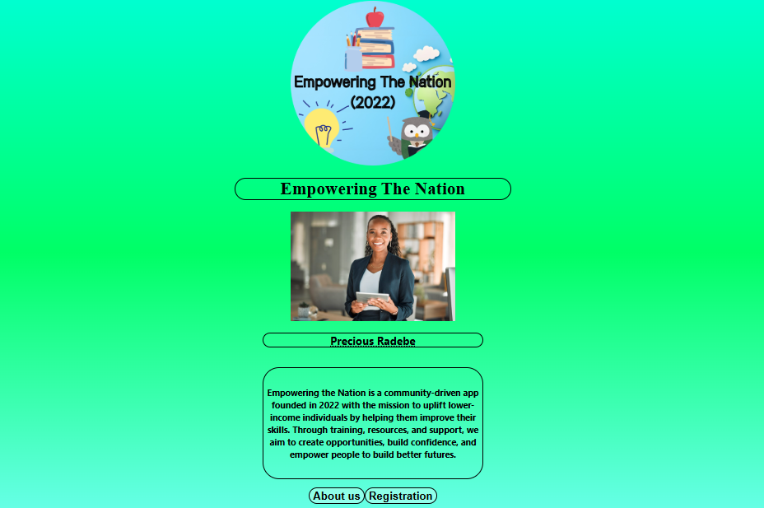
Welcome Page
This page introduces the Empowering The Nation (2022) app by showing its logo, title, and a profile (Precious Radebe) to give a personal touch, along with a mission statement that explains how the app helps individuals improve skills, build confidence, and create opportunities. At the bottom, there are two buttons: About Us for learning more about the organization and Registration for users to sign up. The green gradient background was chosen because green symbolizes growth, renewal, and opportunity, reflecting the app’s goal of uplifting and empowering people in a welcoming way.(ETN,2022;Binary brains,2025)

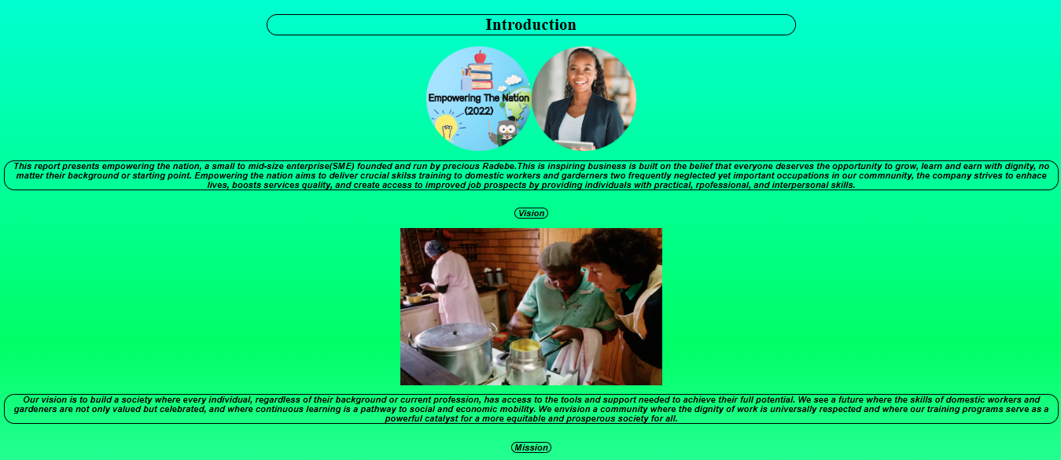
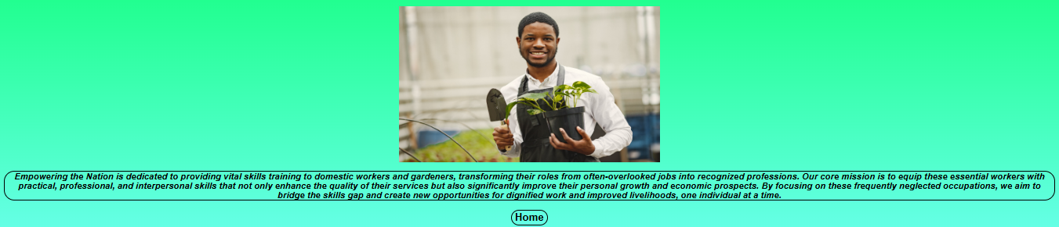
About Us Page
The About Us page for Empowering the Nation (2022) introduces the organization and its mission.

It explains that Empowering the Nation, founded by Precious Radebe, is a community-driven initiative dedicated to helping people from all backgrounds gain valuable skills, confidence, and opportunities for a better future. The page highlights the organization’s commitment to providing training for domestic workers and gardeners, enabling them to transform their roles into recognized and respected professions.

A key focus is ensuring workers receive practical, professional, and employable skills, which not only improve their own livelihoods but also contribute to economic growth and stronger communities.

The green gradient background was chosen to symbolize growth, hope, and renewal, perfectly matching the vision of uplifting and empowering individuals. At the bottom, a Home button helps users navigate back easily.

This page communicates both the values and purpose of Empowering the Nation, while building trust and inspiring users to engage with the initiative.

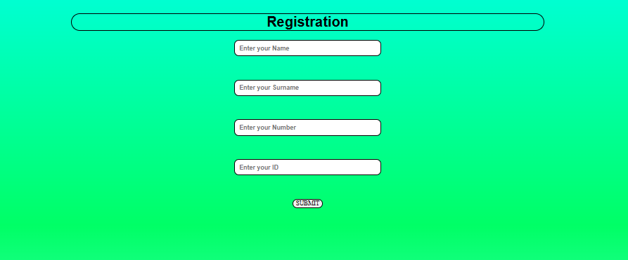
Registration Page
This is the registration page for the company Empowering the Nation (2022).
- Name – where the user types their first name.
- Surname – where the user enters their family or last name.
- Number – for providing a valid contact number, allowing the company to communicate with the registrant.
- ID – for entering an official identification number to verify identity and avoid duplicates.

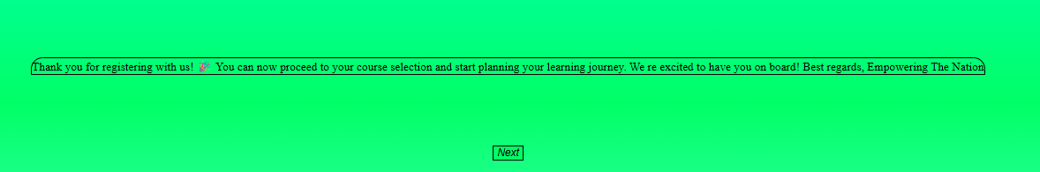
Thank you, page,
This is the Thank You page for Empowering the Nation (2022).

It confirms that the user’s registration was successful with a message of appreciation:

“Thank you for registering with us! You can now proceed to your course selection and start planning your learning journey. We’re excited to have you on board! Best regards, Empowering the Nation.”

The page reassures users, gives clear next steps, and includes a “Next” button to continue to course selection.

Phase-3
(assigned to ST10497775)
Objectives:
Provided detailed designs for the mobile app which includes the user interface,colours,functionality,buttons,links, design for each screen is required

Mobile app
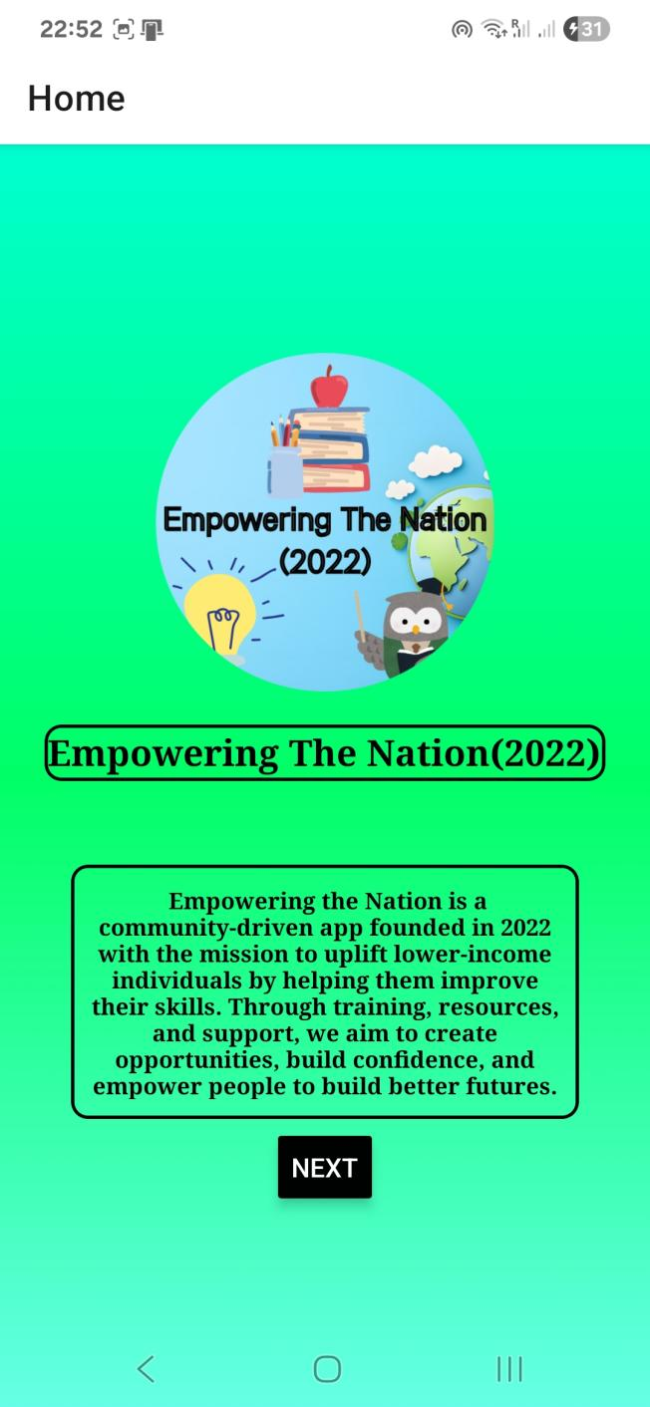
Based on the scenario, the key focus is to enable people to register for the course. Since course registration cannot be completed without obtaining their credentials, the agreed way forward is to design and create pages/frames specifically for credential acquisition. This step will ensure that all required information is collected properly before moving ahead with the registration course process.
Frame-1
landing page mock up for Empowering The Nation founded in 2022, a community-driven app created to uplift lower-income individuals. The app’s mission is to provide training, resources, and support to help people improve their skills, build confidence, and create better opportunities for their future. It features a clear title, a short description of its purpose, and a prominent Next button to encourage users to join, with development credited to binary brains. ( ETN,2022; Binary brains)

(Still in Development Further Changes will be implemented;)

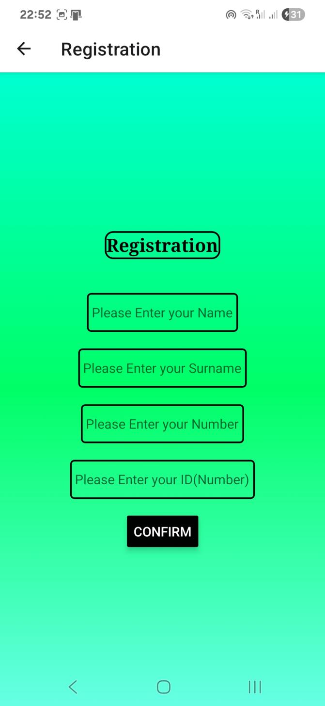
Frame-2
This screen is part of the registration process for the Empowering the Nation app. It is a credential acquisition page, where users are required to provide personal details such as their name, surname, phone number, and ID. Once the fields are completed, pressing the Confirm button will take the user further into the next Screen.

You would have reached this screen by first clicking the “Next” button on the landing page. That action transitions the user into the registration flow, starting with collecting the essential personal information needed for course
enrollment.( ETN,2022; Binary brains,2025)

(Still in Development Further Changes will be implemented;)

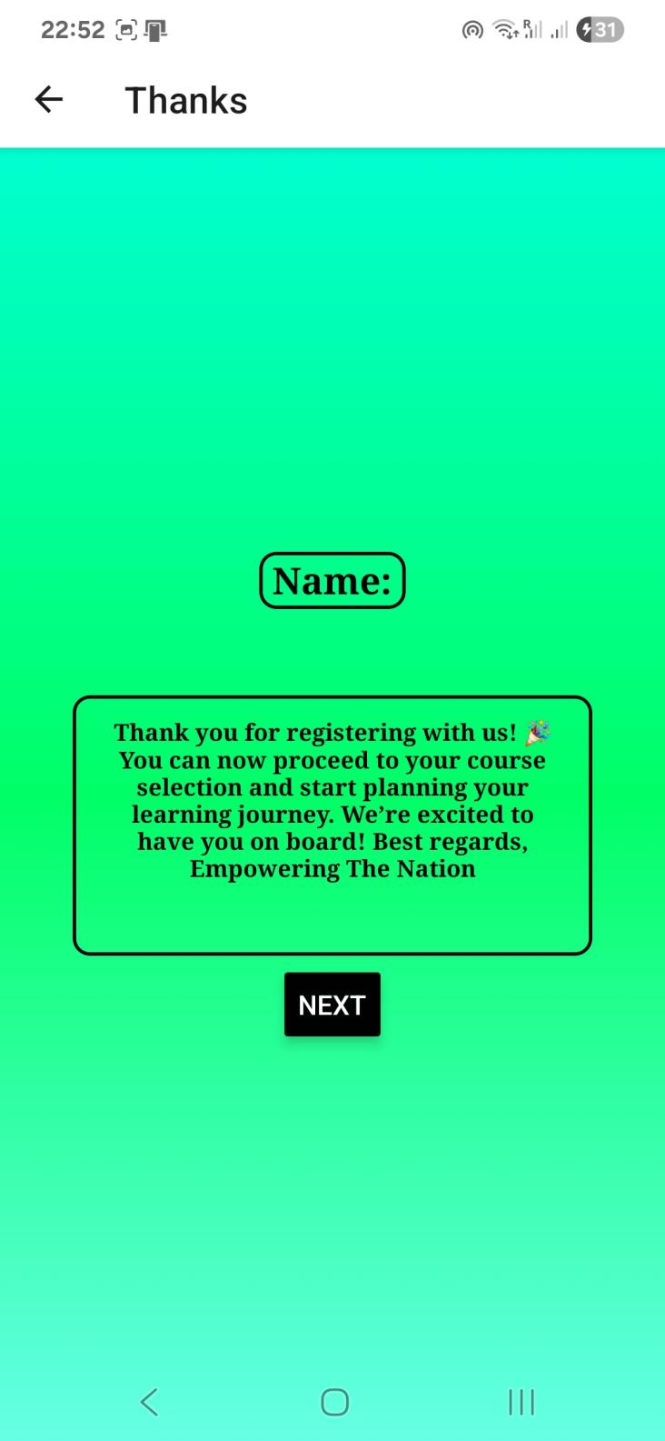
Frame-3
This screen in the Empowering The Nation app serves as a confirmation page. It displays the user’s their name, This screen follows the credential acquisition page, where users entered their personal information. After clicking the "Confirm" button on the previous screen, u and proceed further in the
registration process with course selection next up.( ETN,2025;Binary brains,2025)

(Still in Development Further Changes will be implemented;)

Table of libraries and components used

Library | Component | Explanation | Reference
React Native | View | Basic container component for layout and design. | (React Native, 2025)
React Native | Scroll View | Enables scrolling content vertically or horizontally. | (React Native, 2025)
React Native | Text Input | Used to create input fields such as a search bar. | (React Native, 2025)
React Native | Touchable Opacity | Used to create interactive buttons, such as a home button. | (React Native, 2025)

2.Milestone 3

New changes
Following the completion of Milestone 2, Milestone 3 introduces additional enhancements and updates to the website to ensure improved user experience, updated functionality, and better visual storytelling. Below are the detailed descriptions of the new and updated pages developed during this phase. . (ETN,2025; Binary brains,2025)

Website
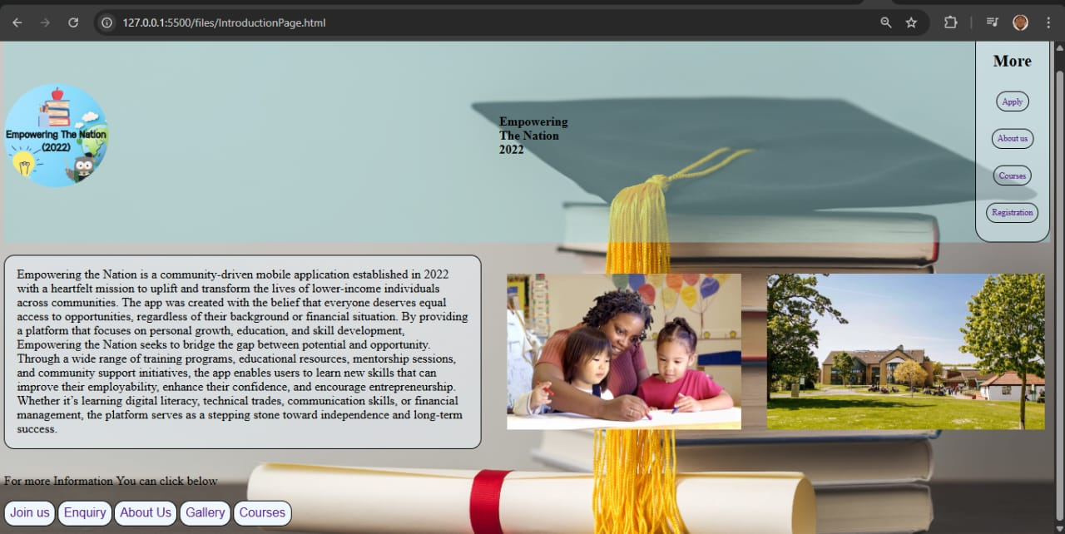
Home page
The Home Page introduces Empowering the Nation as an educational institution focused on uplifting individuals through skill development and training. It features the institution’s logo, a brief welcome message, and clear navigation buttons to guide users to other parts of the website such as About Us, Apply, and Registration. (ETN,2025; Binary brains,2025)

What makes the Home Page visually distinct is its unique background, which symbolizes growth, opportunity, and a fresh start. This background sets it apart from all other pages on the website, giving users a strong first impression and reinforcing the institution’s commitment to empowerment and positive change. ( still in progress)

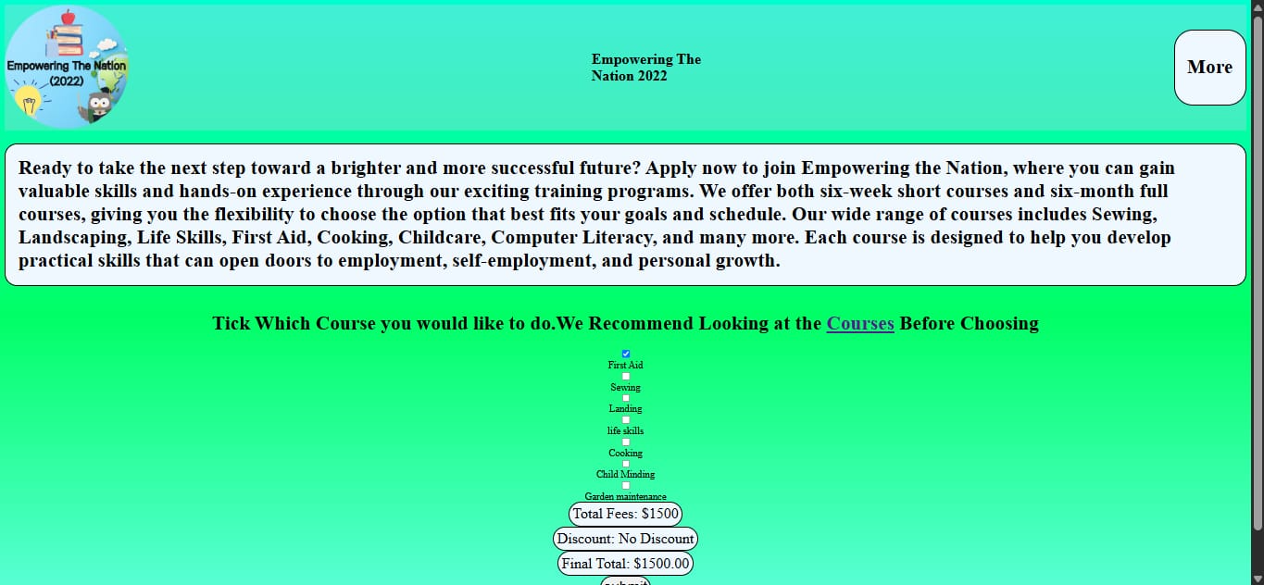
Apply page
The Apply Page enables prospective students to submit applications for courses available at the institution. Users may choose their desired course, enter personal details, and submit any required documents. This page simplifies the process for users to start their experience with Empowering the Nation. ( still in progress)

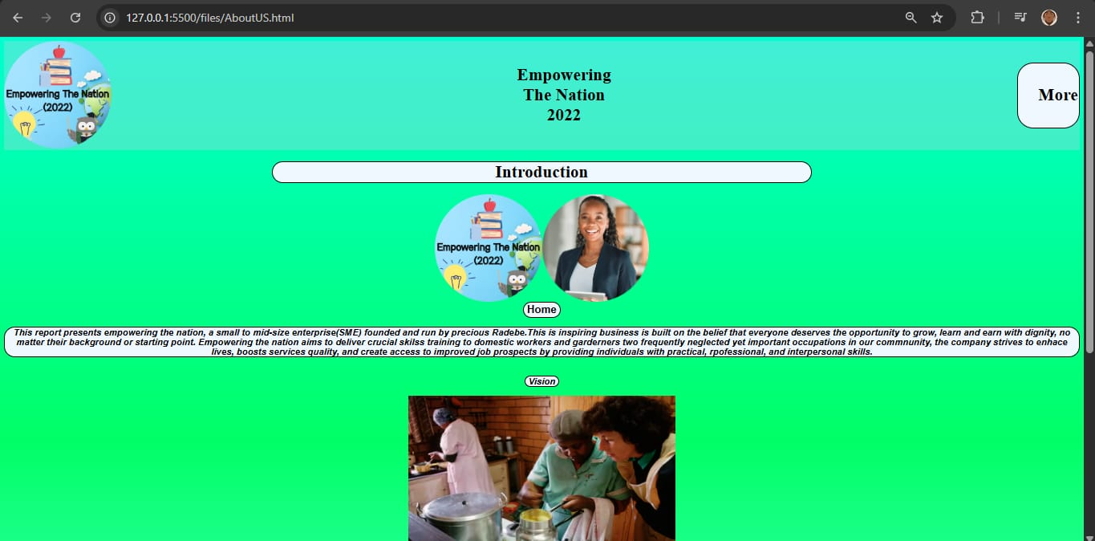
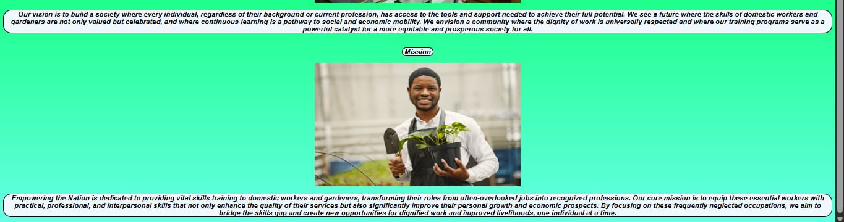
About us page
The About Us section outlines the history and purpose of Empowering the Nation. It emphasizes the institution's dedication to offering education and training that assist individuals in acquiring practical skills, enhancing confidence, and increasing their employment prospects. It also provides details about the founder and the team. . (ETN,2025; Binary brains,2025)

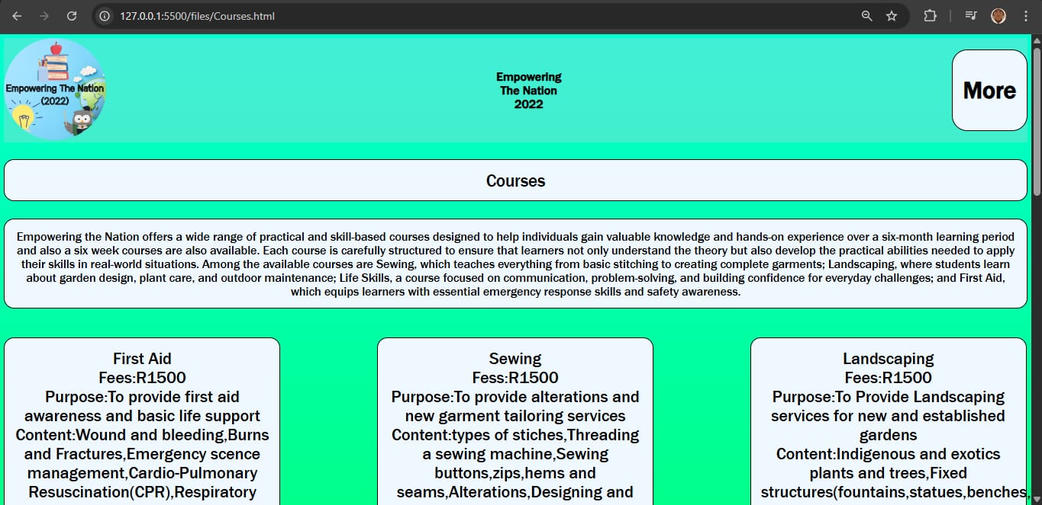
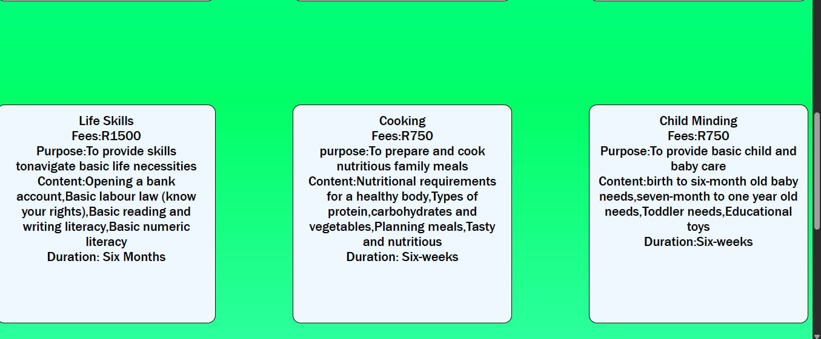
Course information page
This page offers specific information regarding the training programs provided by Empowering the Nation. It contains the titles of the offered courses, a brief description of what each course entails, and the overall price for each. The design is straightforward and easy to navigate, assisting students in selecting the appropriate course for their objectives. It aims to provide users with all the information required prior to registration or application, ensuring they select a course that aligns with their interests and needs. (ETN,2025; Binary brains,2025)

(still in progress)

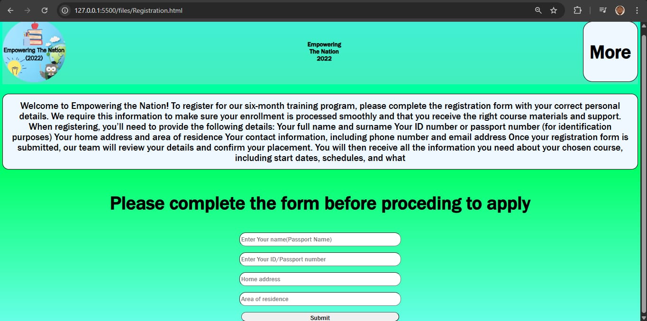
Registration page
The Registration Page enables new students to enrol by providing their personal information, including name, surname, phone number, and ID. The form guarantees that precise information is gathered, allowing students to be registered in the appropriate course. The website is intuitive and simple to explore. (ETN,2025; Binary brains,2025)

( still in progress)

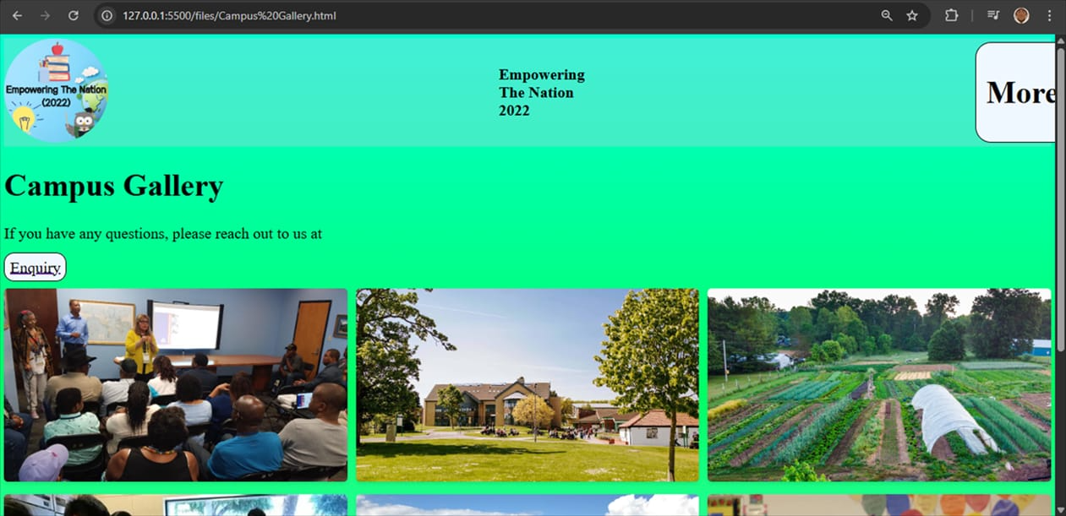
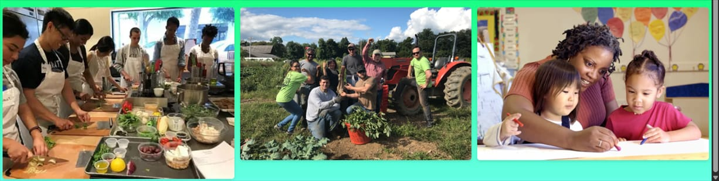
Campus gallery page
The Gallery Page shows real photos and videos from the campus, training sessions, and student activities. It gives visitors a look at the learning environment and shows the positive impact the institution has had in the community. (ETN,2025; Binary brains,2025)

(still in progress)

Mobile app
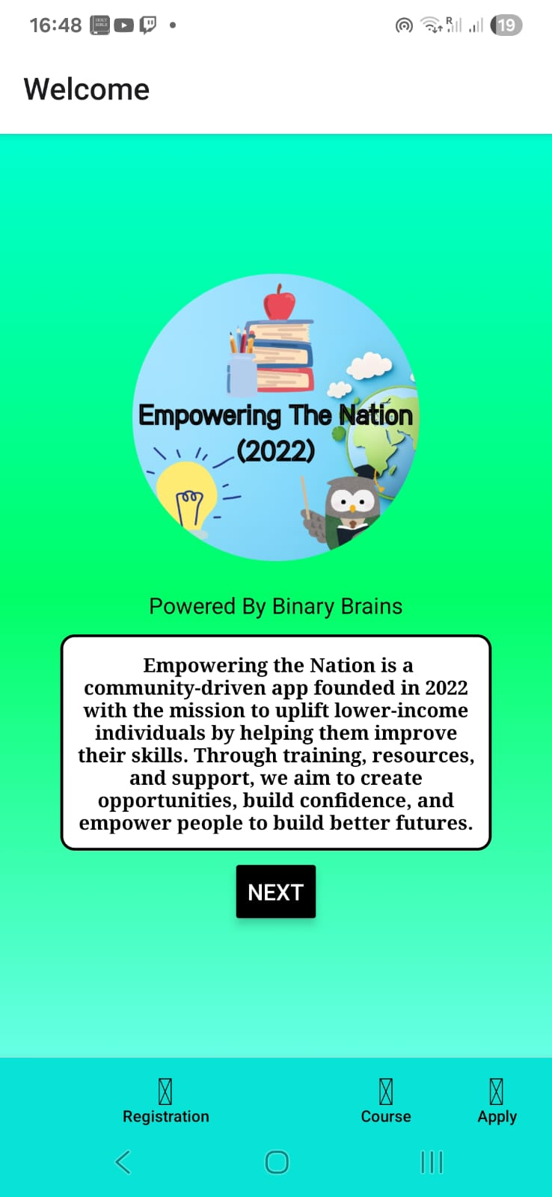
First screen
The Welcome Screen is what users encounter first when they launch the Empowering the Nation (2022) mobile application. The app is presented with a cheerful and vibrant design, featuring a green gradient background that represents growth and potential. In the middle is the application’s logo, accompanied by a short overview that describes its aim: to assist low-income individuals in enhancing their skills and creating better futures. The display highlights the app's mission and vision, clearly indicating from the beginning what the platform represents. The phrase "Powered by Binary Brains" acknowledges the creators, while a "NEXT" button located at the bottom directs users to proceed in the application. At the bottom, navigation icons for Registration, Course, and Apply are displayed, providing easy access to important sections of the app. (ETN,2025; Binary brains,2025)

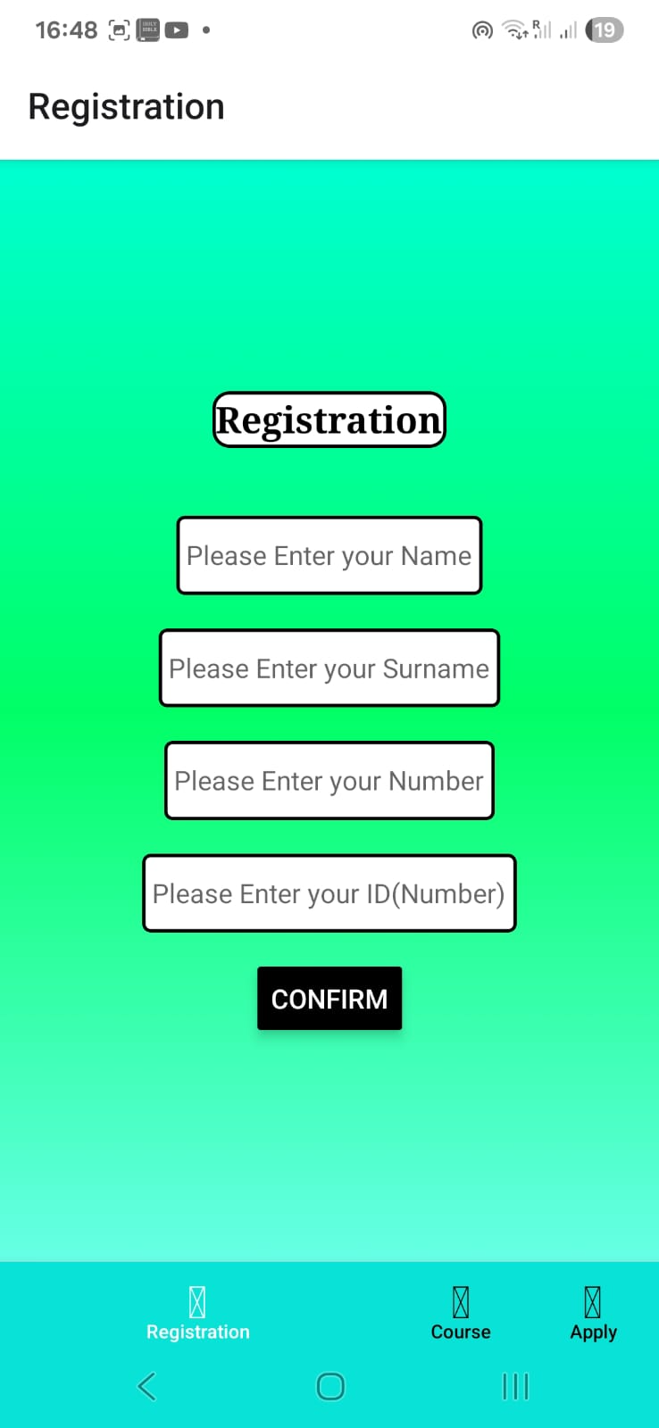
Second screen
The Registration Screen enables new users to create an account for the Empowering the Nation app. It consists of four input areas for gathering necessary information: Name, Surname, Phone Number, and ID Number. This data is essential to enrol every user and guarantee they obtain tailored access to courses and notifications.
The layout is neat and easy to use, featuring white input boxes distinctly marked for every section. A prominent "CONFIRM" button at the bottom finalizes the procedure. Similar to the other displays, it features a green gradient backdrop to ensure visual uniformity and embody the app's theme of growth and empowerment. (ETN,2025; Binary brains,2025)

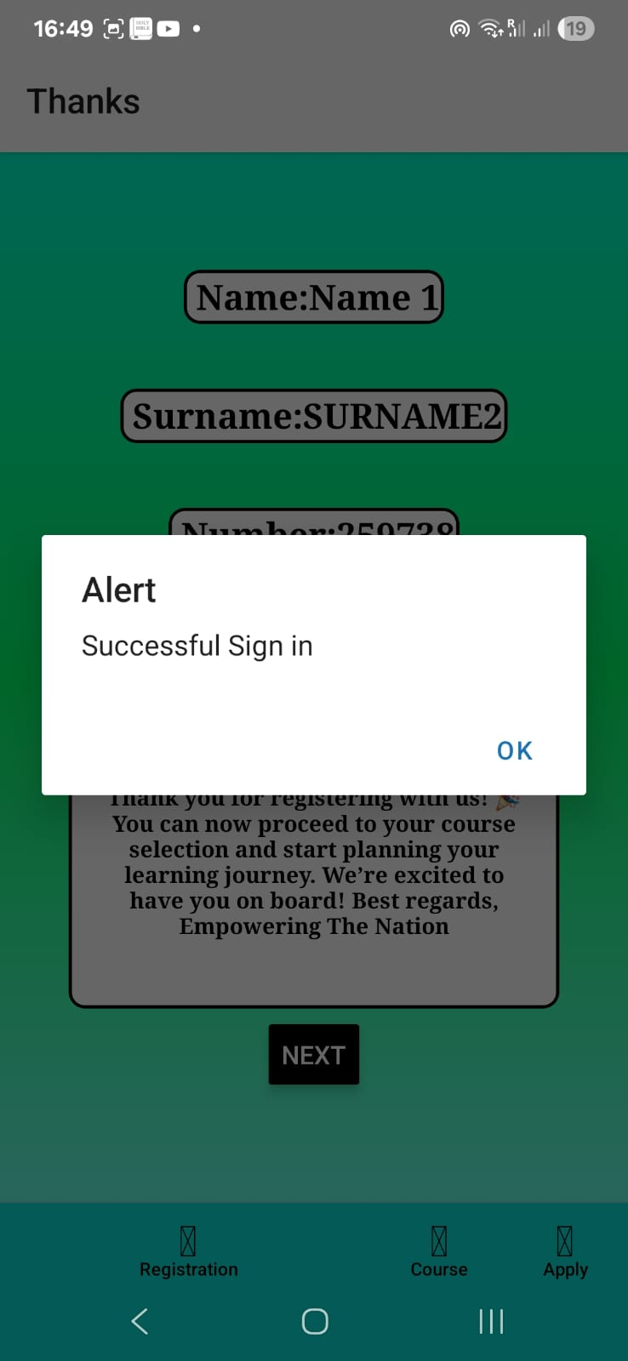
Third screen
· Screen Title: Name: Name 1 | Surname: SURNAME2
· Purpose: To confirm that the user's registration was successful and display a summary of their entered data.
· Content Details:
· User Data: Displays the registered name and surname ("Name 1" and "SURNAME2"). The capitalization suggests these might be placeholder or example entries.
· Alert Box: A green "Alert" box with the message "Successful Sign in" and an "OK" button. This is a clear success feedback mechanism.
· Welcome Message: A warm, detailed message thanking the user for registering and encouraging them to proceed to course selection.
· Call to Action: A "NEXT" button to move the user forward in their journey. (ETN,2025; Binary brains,2025)

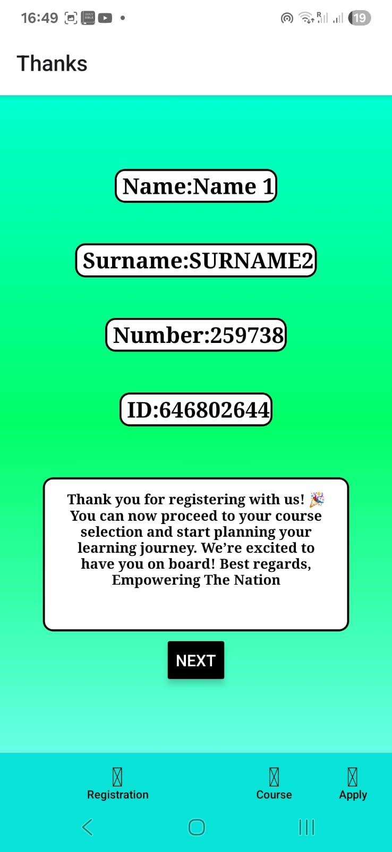
Forth screen
Registration Summary with ID

· Screen Title: Name: Name 1 | Surname: SURNAME2
· Purpose: This appears to be a subsequent or alternative version of the success screen, providing the user with a unique identification number.
· Content Details:
· User Data: Repeats the user's name and surname.
· User ID: Provides two key numbers:
· Number: 259738 (This is likely the user's application or membership number).
· D: 646802644 (This could be a unique device ID or a different reference code).
· Welcome Message: The same welcoming message as in the previous screenshot is displayed.
· Call to Action: A "NEXT" button. (ETN,2025; Binary brains,2025)

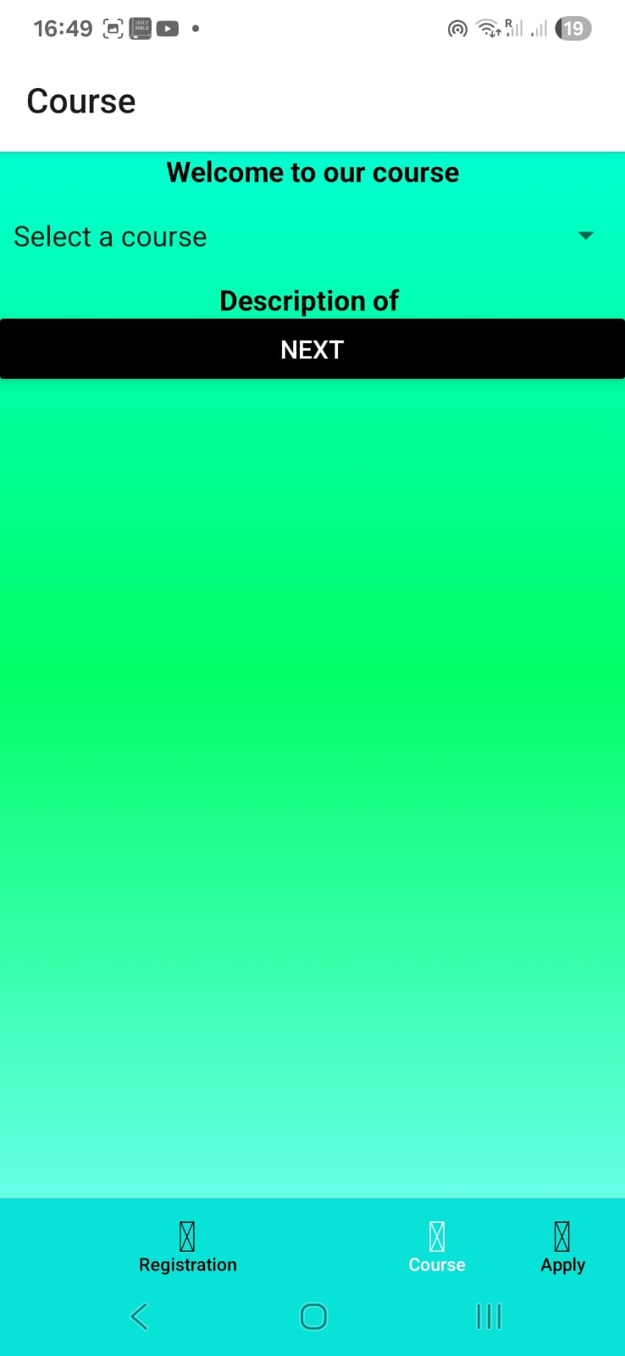
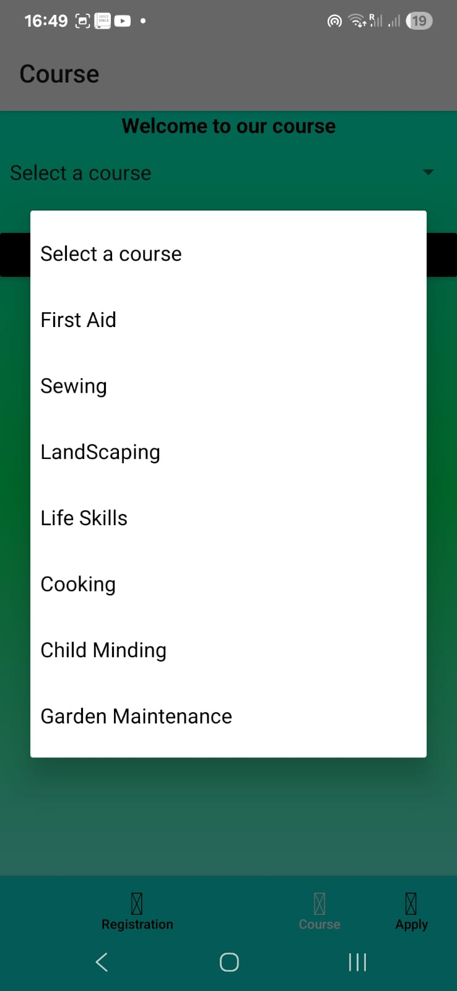
Fifth screen
Course Selection Menu

· Screen Title: Course
· Purpose: To allow the user to browse and select from the available courses offered by the application.
· Content Details:
· Header: "Welcome to our course" and "Select a course".
· Course List: A bulleted list of seven available courses:
· First Aid
· Sewing
· Landscaping
· Life Skills
· Cooking
· Child Minding
· Garden Maintenance
· Navigation: The "Course" tab in the bottom navigation is now active.
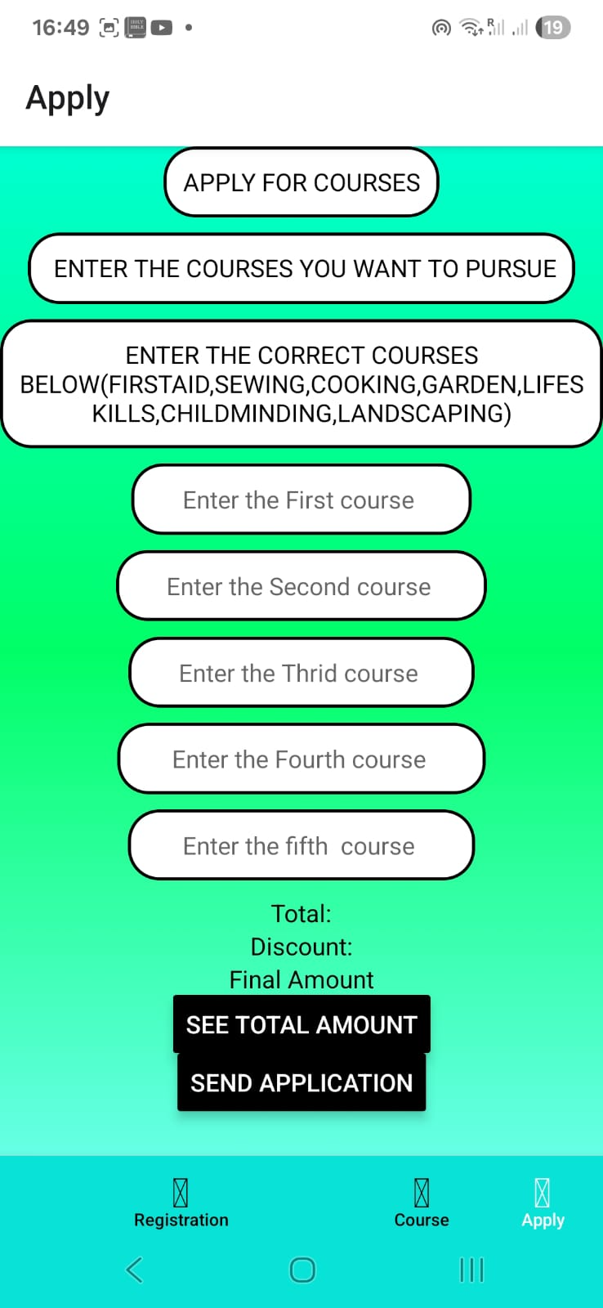
sixth screen
Application and Payment for Course
· Screen Heading: Apply
· Objective: This is the concluding phase where the user officially submits their application for selected courses and reviews the related expenses.
· Content Information:
· Title: "ENROLL IN COURSES".
· Guidelines: Participants are instructed to "INPUT THE RIGHT COURSES BELOW" and a list of the offered courses (with some misspellings, such as "FIRSTAID", "LIFES KILLS", "GARDEN") is supplied for reference.
· Input Fields: Five options for selecting courses (First, Second, Third, Fourth, Fifth).
· Payment Overview: A part displaying "Total:", "Discount:", and "Final Amount", signifying this is a paid service that may include discounts.
· Buttons for Action:
· VIEW TOTAL COST: Determines and shows the price according to the chosen courses.
· SUBMIT APPLICATION: Completes and sends the application.
· Navigation: The "Submit" tab is highlighted. (ETN,2025; Binary brains,2025)

Table of libraries and components used

Library | Component | Explanation | Reference
React Native | View | Basic container component for layout and design. | (React Native, 2025)
React Native | Scroll View | Enables scrolling content vertically or horizontally. | (React Native, 2025)
React Native | Text Input | Used to create input fields such as a search bar. | (React Native, 2025)
React Native | Touchable Opacity | Used to create interactive buttons, such as a home button. | (React Native, 2025)

Reference list

- Colour combinations, 2025. Colour Psychology [online] available at: < URL: https://www.colorpsychology.org/green/>

[accessed 10 September 2025]
- Canva,2025. Canva design platform [ Online] available at: < https://www.canva.com>
[Accessed 6 September 2025]

- Figma,2025. Figma design [Online] available at: < https://www.figma.com/files/team/1532070079899147819/recents-and-sharing?fuid=1532070077629378828.>

[Accessed 6 September2025]

- React Native,2025. React Native Components Documentation. [Online] available at: < https://reactnative.dev/docs/components-and-apis>

[Accessed 15 October 2025]

AI disclosure on this report
Section where AI was used:
- Table and website, mobile app descriptions in both milestones. The reference list.
AI Tool ChatGPT5 and DeepSeek
Purpose:
- In this report we asked Ai to generate the library table for us and the reference list. We also asked it to polish our grammar in the lines.
- Descriptions for each screen page both website and app
Prompt used:
“Can you provide a reference list for everything in this chat”

“Give me something that simple explains the homepage, apply page, about us page, courses information page, registration page and gallery page”

“Can you provide me a well detailed project report”

Dates used:
- 10 September 2025 – 15 October 2025

Screenshots of conversations:

- 
 